Step 1:- Creating Extraction pipelines from multiple client data sources to our data warehouse.

Pipeline 1- Amazon RDS or client relational database to Hive/HBase.

Ingestion Tool used: Sqoop

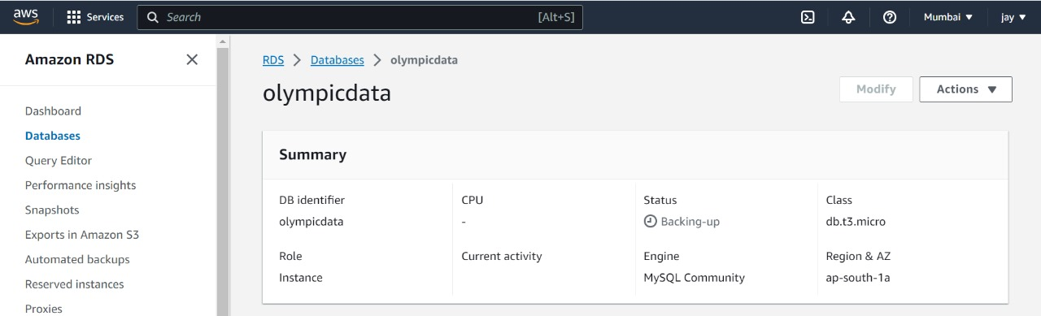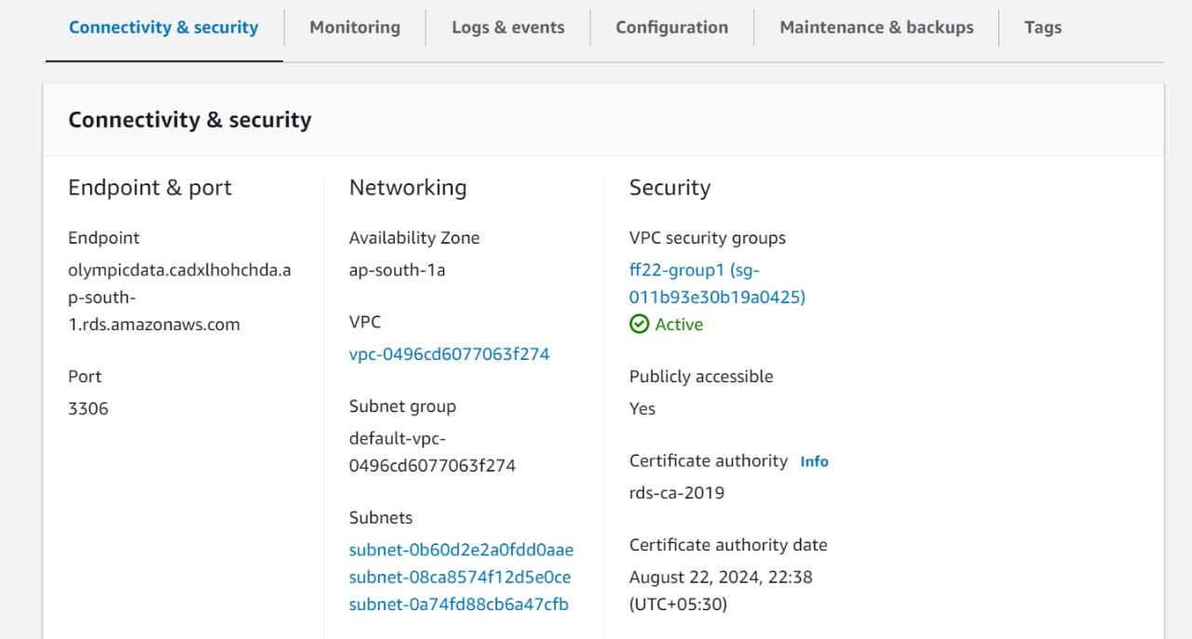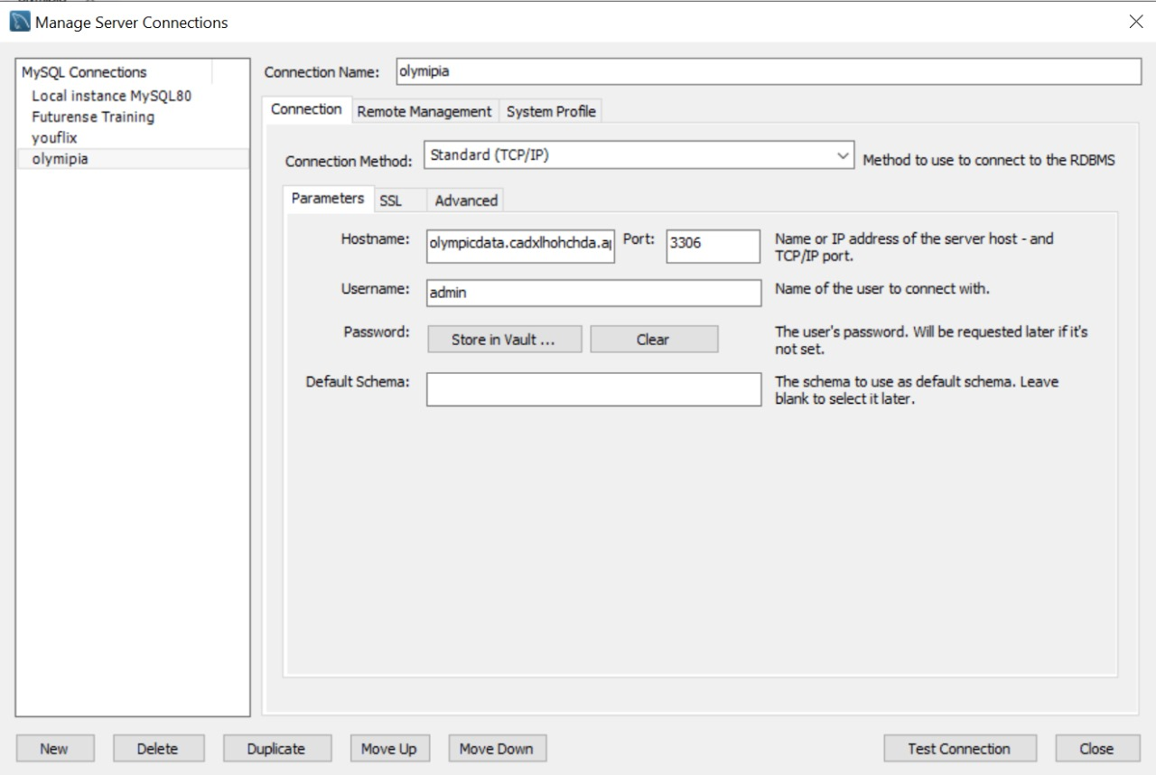

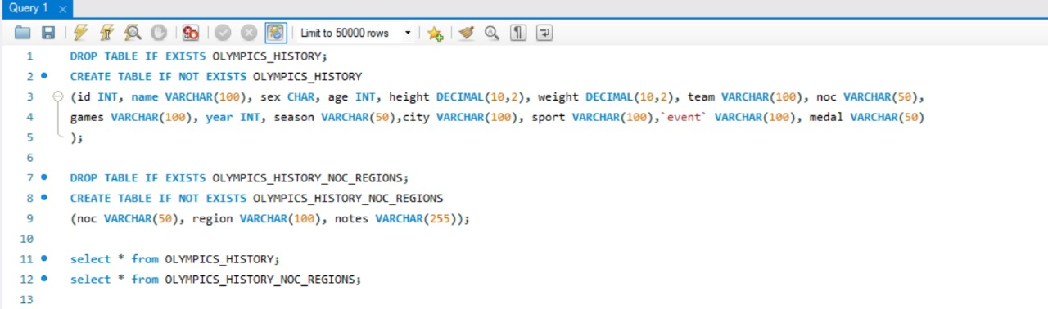

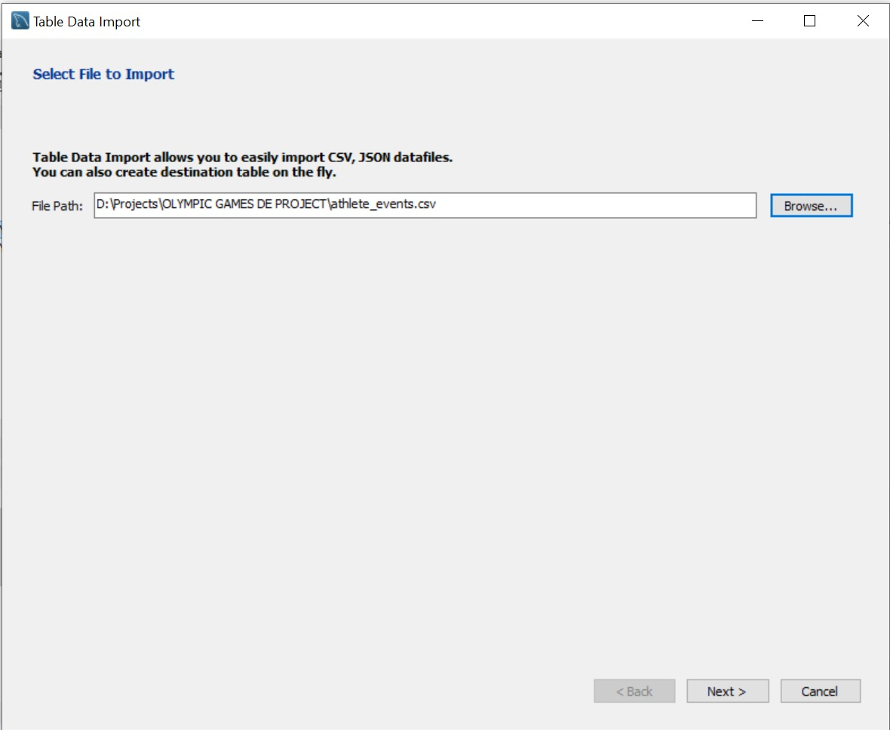



sqoop import-all-tables --connect jdbc:mysql://olympicdata.cadxlhohchda.ap-south-1.rds.amazonaws.com:3306/olympicdata --username admin --password olympia1 --hive-import --fields-terminated-by ',' -m 1;



sqoop import-all-tables --connect jdbc:mysql://localhost:3306/olympicdb --username root --password cloudera –hive-import –fields-terminated-by ‘,’ -m 1;

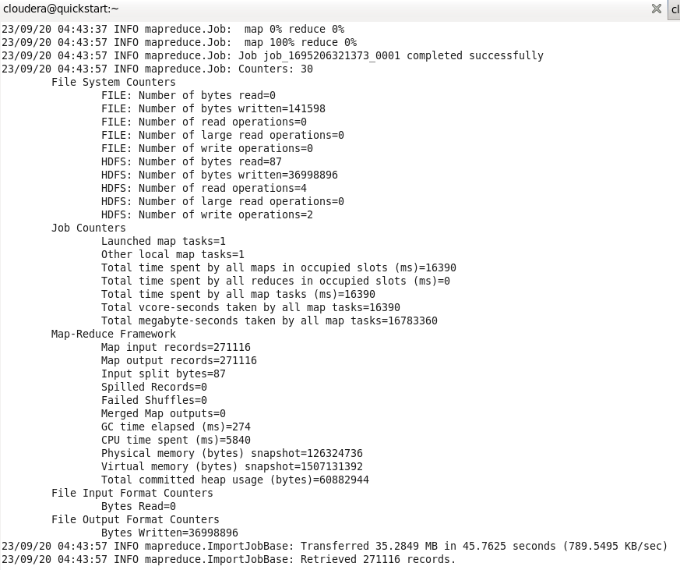

Pipeline 2- Amazon S3 Bucket to SnowFlake data warehouse.

Ingestion Tool used: Copy into

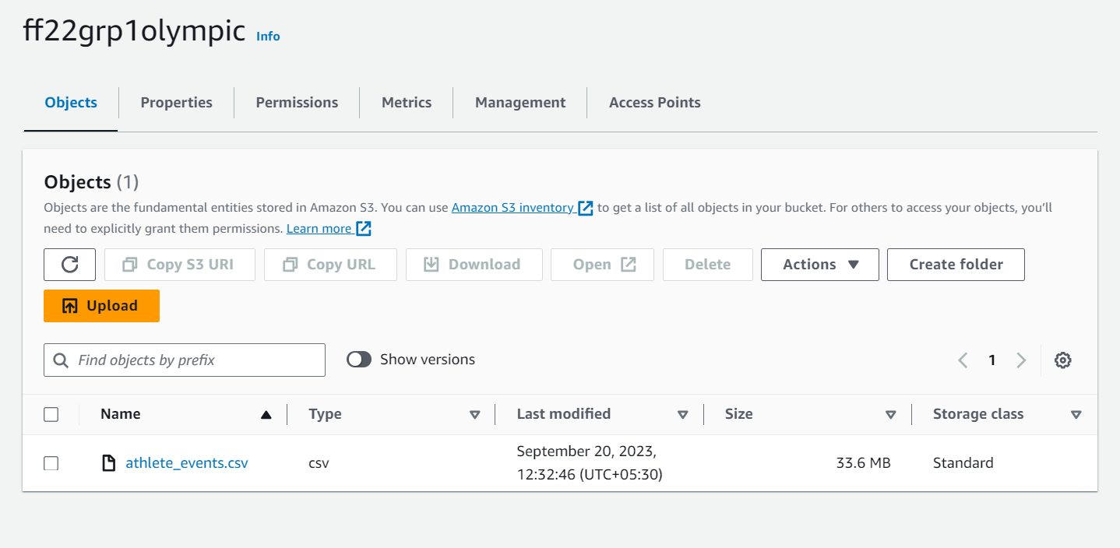

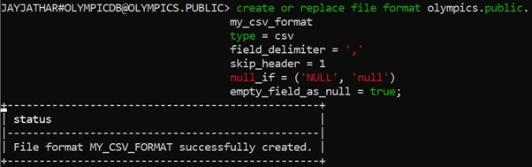

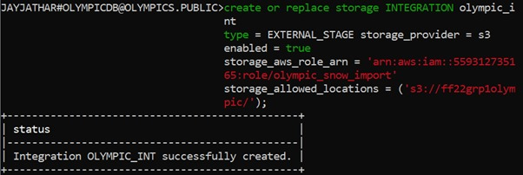

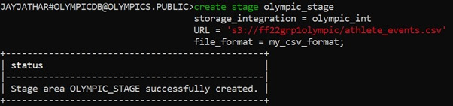

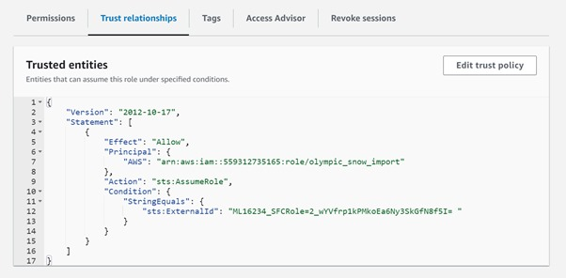

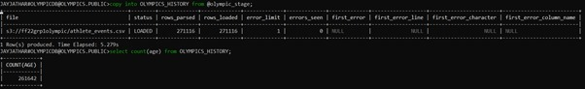

Pipeline 3- Azure Blob Container to SnowFlake data warehouse.

Ingestion Tool used: Snow Pipe

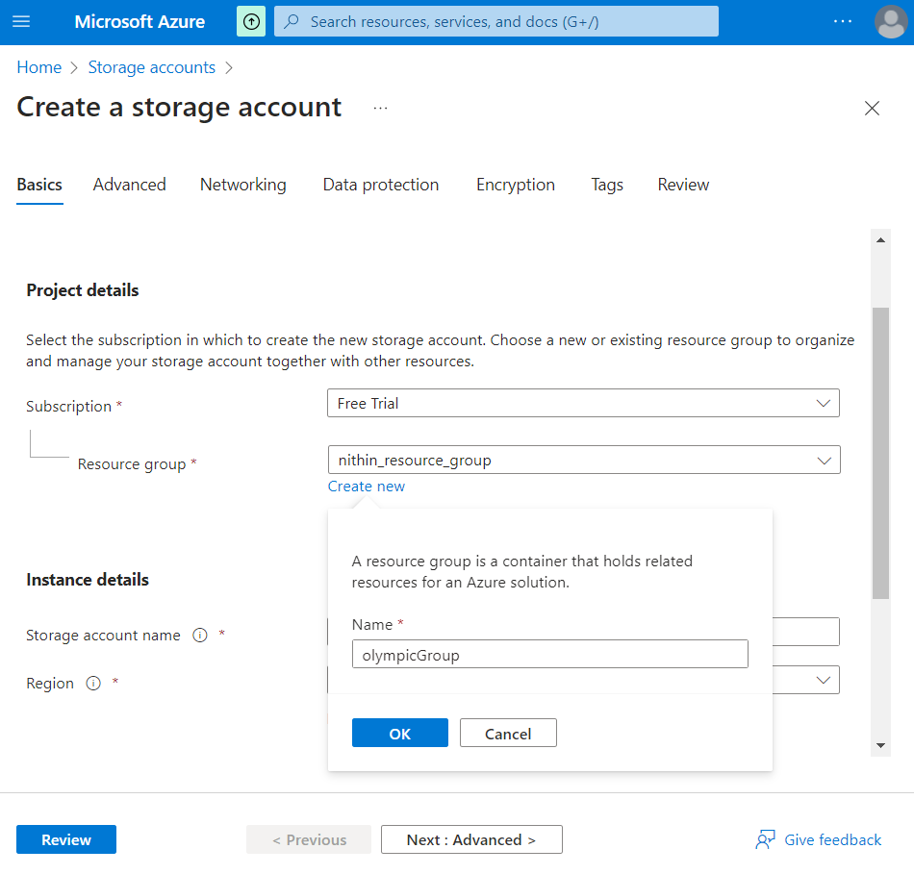

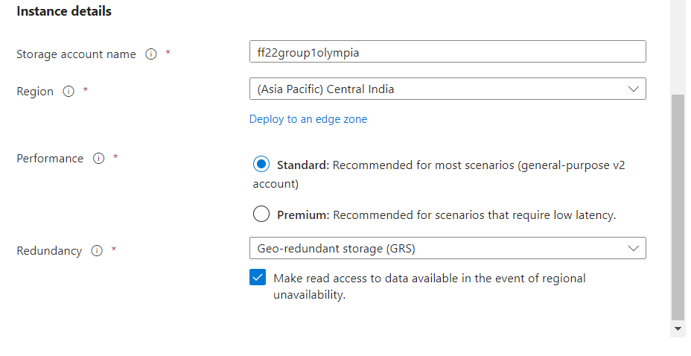

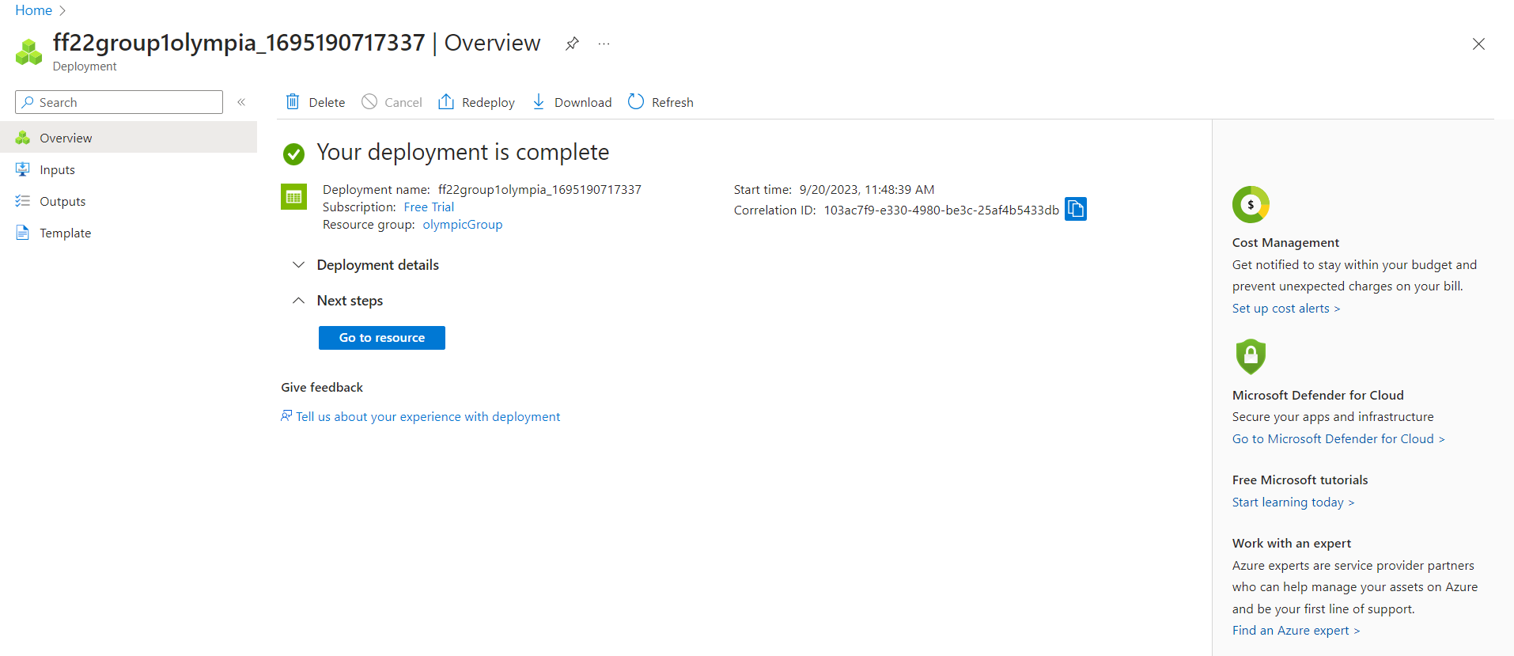

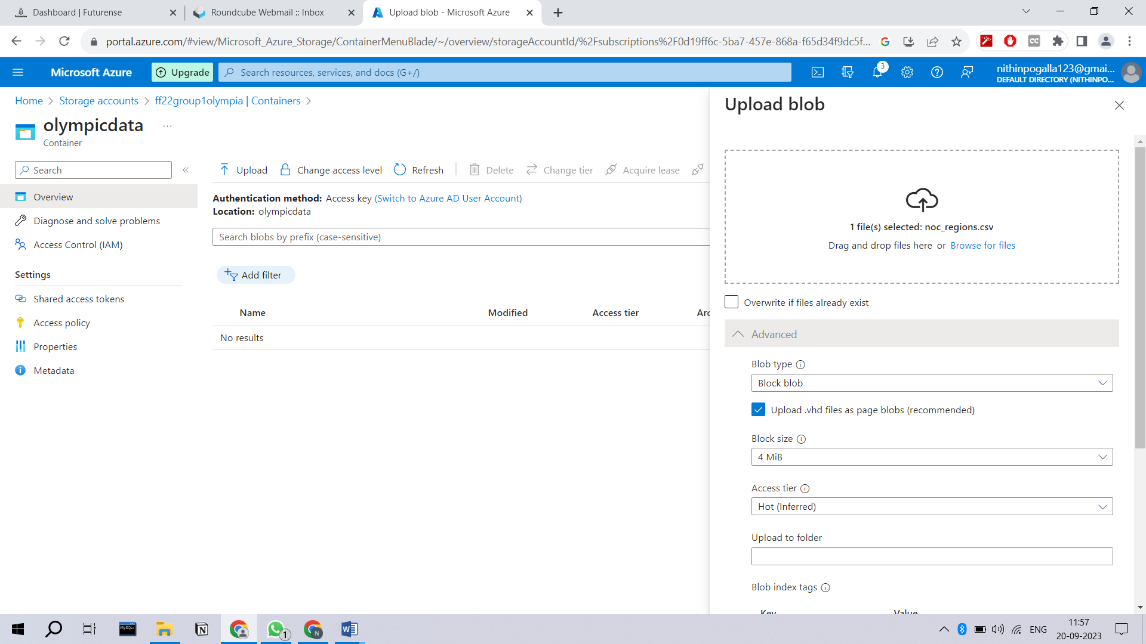

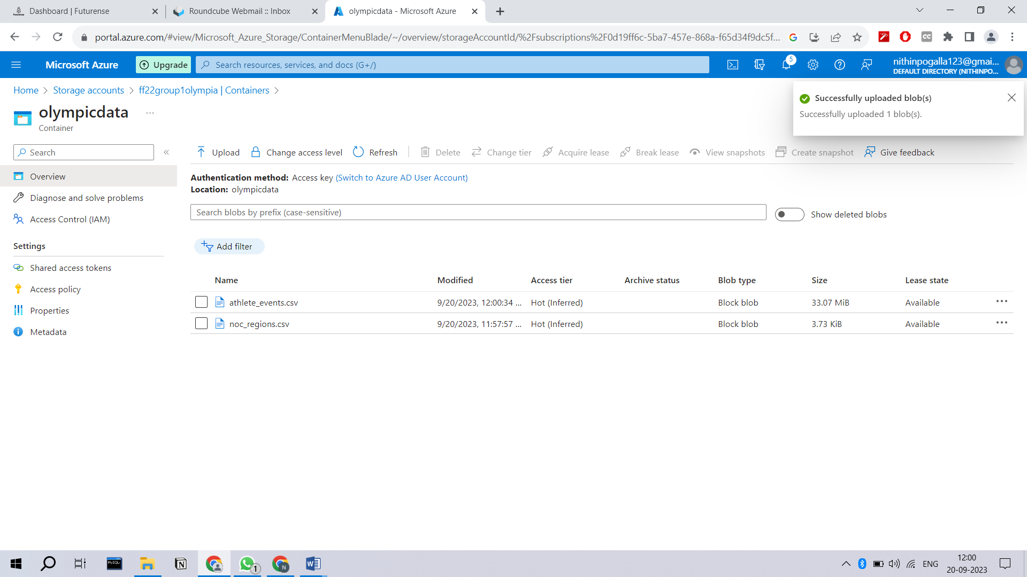

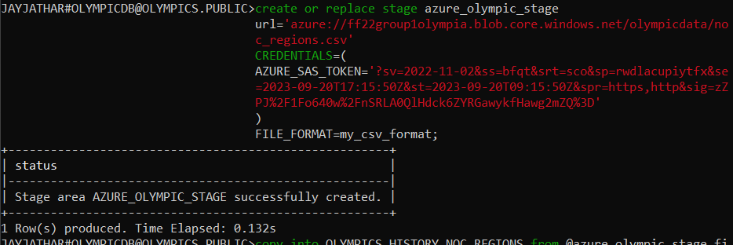



Step 2:- Transformation or Analysis of data in HIVE, HBASE, SNOWFLAKE according to the client requirements.

Analysis 1 – Snowfake

-- 1. How many Olympics games have been held?

SELECT COUNT(DISTINCT games) AS Total_Games FROM olympics_history;

-- 2. List down all Olympics games held so far.

SELECT DISTINCT games FROM olympics_history;

-- 3. Mention the total number of nations who participated in each Olympics game?

SELECT games, COUNT(DISTINCT n.region) AS Total_Nations

FROM olympics_history o

JOIN olympics_history_noc_regions n ON o.noc = n.noc

GROUP BY games;

-- 4. Which year saw the highest and lowest number of countries participating in Olympics?

WITH cte AS (

SELECT year, COUNT(DISTINCT n.region) AS Countries

FROM olympics_history o

JOIN olympics_history_noc_regions n ON o.noc = n.noc

GROUP BY year

)

SELECT year, countries

FROM (

SELECT year, countries, DENSE_RANK() OVER (ORDER BY countries) AS l, DENSE_RANK() OVER (ORDER BY countries DESC) AS h

FROM cte

) WHERE l = 1 OR h = 1;

-- 5. Which nation has participated in all of the Olympic games?

WITH cte AS (

SELECT n.region AS nations, COUNT(DISTINCT games) AS game_count

FROM olympics_history o

JOIN olympics_history_noc_regions n ON o.noc = n.noc

GROUP BY nations

)

SELECT nations FROM cte WHERE game_count = (SELECT COUNT(DISTINCT games) FROM olympics_history);

-- 6. Identify the sport which was played in all summer Olympics.

WITH cte AS (

SELECT sport, COUNT(DISTINCT games) AS game_count

FROM olympics_history

WHERE season = 'Summer'

GROUP BY sport

)

SELECT sport FROM cte WHERE game_count = (SELECT COUNT(DISTINCT games) FROM olympics_history WHERE season = 'Summer');

-- 7. Which sports were just played only once in the Olympics?

SELECT sport, COUNT(DISTINCT games) AS game_count

FROM olympics_history

GROUP BY sport

HAVING game_count = 1;

-- 8. Fetch the total number of sports played in each Olympic game.

SELECT games, COUNT(DISTINCT sport) AS Total_Sports FROM olympics_history GROUP BY games;

-- 9. Fetch details of the oldest athletes to win a gold medal.

SELECT name, age, games, sport, medal

FROM olympics_history

WHERE medal = 'Gold' AND age = (SELECT MAX(age) FROM olympics_history WHERE medal = 'Gold');

-- 10. Find the ratio of male and female athletes participated in all Olympic games.

WITH cte AS (

SELECT DISTINCT name, sex FROM olympics_history

)

SELECT

SUM(CASE WHEN sex = 'M' THEN 1 ELSE 0 END) / (SELECT COUNT(DISTINCT name) FROM olympics_history) * 100 AS male_ratio,

SUM(CASE WHEN sex = 'F' THEN 1 ELSE 0 END) / (SELECT COUNT(DISTINCT name) FROM olympics_history) * 100 AS female_ratio

FROM cte;

-- 11. Fetch the top 5 athletes who have won the most gold medals.

SELECT name, COUNT(medal) AS medalsWon

FROM olympics_history

WHERE medal = 'Gold'

GROUP BY name

ORDER BY medalsWon DESC

LIMIT 5;

-- 12. Fetch the top 5 athletes who have won the most medals (gold/silver/bronze).

SELECT name, COUNT(medal) AS medalsWon

FROM olympics_history

GROUP BY name

ORDER BY medalsWon DESC

LIMIT 5;

-- 13. Fetch the top 5 most successful countries in Olympics. Success is defined by the number of medals won.

SELECT nr.region, COUNT(oh.medal) AS medalsWon

FROM olympics_history oh

JOIN olympics_history_noc_regions nr ON oh.noc = nr.noc

GROUP BY nr.region

ORDER BY medalsWon DESC

LIMIT 5;

-- 14. List down the total gold, silver, and bronze medals won by each country.

WITH MedalCounts AS (

SELECT

noc,

SUM(CASE WHEN medal = 'Gold' THEN 1 ELSE 0 END) AS GoldCount,

SUM(CASE WHEN medal = 'Silver' THEN 1 ELSE 0 END) AS SilverCount,

SUM(CASE WHEN medal = 'Bronze' THEN 1 ELSE 0 END) AS BronzeCount

FROM olympics_history

GROUP BY noc

)

SELECT

nr.region,

SUM(mc.GoldCount) AS GoldWon,

SUM(mc.SilverCount) AS SilverWon,

SUM(mc.BronzeCount) AS BronzeWon

FROM MedalCounts mc

JOIN olympics_history_noc_regions nr ON mc.noc = nr.noc

GROUP BY nr.region

ORDER BY GoldWon DESC, SilverWon DESC, BronzeWon DESC;

-- 15. List down the total gold, silver, and bronze medals won by each country corresponding to each Olympic game.

SELECT n.region, games, SUM(CASE WHEN medal='Gold' THEN 1 ELSE 0 END) AS gold,

SUM(CASE WHEN medal='Silver' THEN 1 ELSE 0 END) AS silver,

SUM(CASE WHEN medal='Bronze' THEN 1 ELSE 0 END) AS bronze

FROM olympics_history o

JOIN olympics_history_noc_regions n ON o.noc = n.noc

GROUP BY n.region, games;

-- 16. Identify which country won the most gold, most silver, and most bronze medals in each Olympic game.

WITH gold_cte AS (

SELECT noc, games, region,

SUM(CASE WHEN medal='Gold' THEN 1 ELSE 0 END) AS gold_medals,

RANK() OVER(PARTITION BY games ORDER BY gold_medals DESC) AS gold_rank

FROM olympics_history

JOIN olympics_history_noc_regions USING(noc)

GROUP BY noc, games, region

),

silver_cte AS (

SELECT noc, games, region,

SUM(CASE WHEN medal='Silver' THEN 1 ELSE 0 END) AS silver_medals,

RANK() OVER(PARTITION BY games ORDER BY silver_medals DESC) AS silver_rank

FROM olympics_history

JOIN olympics_history_noc_regions USING(noc)

GROUP BY noc, games, region

),

bronze_cte AS (

SELECT noc, games, region,

SUM(CASE WHEN medal='Bronze' THEN 1 ELSE 0 END) AS bronze_medals,

RANK() OVER(PARTITION BY games ORDER BY bronze_medals DESC) AS bronze_rank

FROM olympics_history

JOIN olympics_history_noc_regions USING(noc)

GROUP BY noc, games, region

)

SELECT games, g.region AS g_region, s.region AS s_region, b.region AS b_region

FROM gold_cte g

JOIN silver_cte s USING(games)

JOIN bronze_cte b USING(games)

WHERE gold_rank = 1 AND silver_rank = 1 AND bronze_rank = 1

ORDER BY games;

-- 17. Identify which country won the most gold, most silver, most bronze medals, and the most medals in each Olympic game.

WITH gold_cte AS (

SELECT noc, games, region,

SUM(CASE WHEN medal='Gold' THEN 1 ELSE 0 END) AS gold_medals,

RANK() OVER(PARTITION BY games ORDER BY gold_medals DESC) AS gold_rank

FROM olympics_history

JOIN olympics_history_noc_regions USING(noc)

GROUP BY noc, games, region

),

silver_cte AS (

SELECT noc, games, region,

SUM(CASE WHEN medal='Silver' THEN 1 ELSE 0 END) AS silver_medals,

RANK() OVER(PARTITION BY games ORDER BY silver_medals DESC) AS silver_rank

FROM olympics_history

JOIN olympics_history_noc_regions USING(noc)

GROUP BY noc, games, region

),

bronze_cte AS (

SELECT noc, games, region,

SUM(CASE WHEN medal='Bronze' THEN 1 ELSE 0 END) AS bronze_medals,

RANK() OVER(PARTITION BY games ORDER BY bronze_medals DESC) AS bronze_rank

FROM olympics_history

JOIN olympics_history_noc_regions USING(noc)

GROUP BY noc, games, region

),

total_cte AS (

SELECT noc, games, region,

COUNT(medal) AS total_medals,

RANK() OVER(PARTITION BY games ORDER BY total_medals DESC) AS total_rank

FROM olympics_history

JOIN olympics_history_noc_regions USING(noc)

GROUP BY noc, games, region

)

SELECT games, g.region AS g_region, s.region AS s_region, b.region AS b_region, t.region AS total_region

FROM gold_cte g

JOIN silver_cte s USING(games)

JOIN bronze_cte b USING(games)

JOIN total_cte t USING(games)

WHERE gold_rank = 1 AND silver_rank = 1 AND bronze_rank = 1 AND total_rank = 1

ORDER BY games;

-- 18. Which countries have never won a gold medal but have won silver/bronze medals?

WITH cte AS (

SELECT noc,

SUM(CASE WHEN medal='Gold' THEN 1 ELSE 0 END) AS gold_medals,

SUM(CASE WHEN medal='Bronze' OR medal='Silver' THEN 1 ELSE 0 END) AS other_medals

FROM olympics_history

GROUP BY noc

)

SELECT region FROM cte

JOIN olympics_history_noc_regions USING(noc)

WHERE gold_medals = 0 AND other_medals <> 0;

-- 19. In which Sport/event, India has won the highest number of medals.

SELECT sport, COUNT(medal) AS medals

FROM olympics_history

JOIN olympics_history_noc_regions USING(noc)

WHERE region='India'

GROUP BY sport

ORDER BY medals DESC

LIMIT 1;

SELECT event, COUNT(medal) AS medals

FROM olympics_history

JOIN olympics_history_noc_regions USING(noc)

WHERE region='India'

GROUP BY event

ORDER BY medals DESC

LIMIT 1;

-- 20. Break down all Olympic games where India won a medal for Hockey and how many medals in each Olympic game.

SELECT games, COUNT(medal) AS medals

FROM olympics_history

JOIN olympics_history_noc_regions USING(noc)

WHERE region='India' AND sport LIKE '%Hockey%'

GROUP BY games

HAVING medals <> 0

ORDER BY medals DESC;

Analysis 2 – Hive

-- 1. How many Olympics games have been held?

SELECT COUNT(DISTINCT games) AS total_olympic_games FROM olympics_history;

-- 2. List down all Olympics games held so far.

SELECT DISTINCT games AS total_olympic_games FROM olympics_history;

-- 3. Mention the total number of nations who participated in each Olympics game?

SELECT games, COUNT(DISTINCT noc) FROM OLYMPICS_HISTORY GROUP BY games;

-- 4. Which year saw the highest and lowest number of countries participating in Olympics?

SELECT year, nation_part

FROM (

SELECT year, COUNT(DISTINCT noc) AS nation_part

FROM olympics_history

GROUP BY year

ORDER BY nation_part DESC

LIMIT 1

) highest_participation

UNION ALL

SELECT year, nation_part

FROM (

SELECT year, COUNT(DISTINCT noc) AS nation_part

FROM olympics_history

GROUP BY year

ORDER BY nation_part ASC

LIMIT 1

) lowest_participation;

-- 5. Which nation has participated in all of the Olympic games?

SELECT noc

FROM (SELECT COUNT(DISTINCT games) AS cnt_games FROM olympics_history) AS cte, (SELECT noc, COUNT(DISTINCT games) AS cnt

FROM olympics_history

GROUP BY noc

ORDER BY cnt DESC) AS cte2

WHERE cnt_games = cnt;

-- 6. Identify the sport which was played in all summer Olympics.

SELECT sport

FROM (SELECT COUNT(DISTINCT games) AS cnt_games FROM olympics_history WHERE season='Summer') AS cte, (SELECT sport, COUNT(DISTINCT games) AS cnt

FROM olympics_history

WHERE season='Summer'

GROUP BY sport

ORDER BY cnt DESC) AS cte2

WHERE cnt_games = cnt;

-- 7. Which Sports were just played only once in the Olympics?

SELECT sport

FROM (

SELECT sport, COUNT(DISTINCT games) AS total_games

FROM OLYMPICS_HISTORY

GROUP BY sport

HAVING total_games = 1

) AS tt;

-- 8. Fetch the total number of sports played in each Olympic game.

SELECT games, COUNT(DISTINCT sport) AS total_sports_played

FROM olympics_history_optimized

GROUP BY games;

-- 9. Fetch details of the oldest athletes to win a gold medal.

SELECT name, age, games, sport, event

FROM olympics_history_optimized

WHERE medal = 'Gold'

ORDER BY age ASC

LIMIT 1;

-- 10. Find the Ratio of male and female athletes participated in all Olympic games.

WITH athlete_counts AS (

SELECT games, sex, COUNT(DISTINCT name) AS athlete_count

FROM olympics_history_optimized

GROUP BY games, sex

),

total_athletes AS (

SELECT games, SUM(athlete_count) AS total_count

FROM athlete_counts

GROUP BY games

)

SELECT t.games,

m.athlete_count AS male_athletes,

f.athlete_count AS female_athletes,

ROUND(m.athlete_count / f.athlete_count, 2) AS gender_ratio

FROM total_athletes t

JOIN athlete_counts m ON t.games = m.games AND m.sex = 'M'

JOIN athlete_counts f ON t.games = f.games AND f.sex = 'F';

Partitioning table for optimization

CREATE TABLE olympics_history_optimized

(

id INT,

name STRING,

sex STRING,

age INT,

height STRING,

weight STRING,

team STRING,

noc STRING,

games STRING,

year INT,

season STRING,

city STRING,

sport STRING,

event STRING

)

PARTITIONED BY (medal STRING)

CLUSTERED BY (noc)

INTO 5 BUCKETS row format delimited fields terminated by ',' lines terminated by '\n' stored as orc;

INSERT OVERWRITE TABLE olympics_history_optimized PARTITION(medal) SELECT id, name, sex, age, height, weight, team, noc, games, year, season, city, sport, event, medal FROM OLYMPICS_HISTORY;

-- 11. Fetch the top 5 athletes who have won the most gold medals.

SELECT name, COUNT(*) AS gold_medals_count

FROM olympics_history_optimized

WHERE medal = 'Gold'

GROUP BY name

ORDER BY gold_medals_count DESC

LIMIT 5;

-- 12. Fetch the top 5 athletes who have won the most medals (gold/silver/bronze).

SELECT name, COUNT(medal) AS medalsWon

FROM olympics_history_optimized

GROUP BY name

ORDER BY medalsWon DESC

LIMIT 5;

-- 13. Fetch the top 5 most successful countries in Olympics. Success is defined by the number of medals won.

SELECT nr.region, COUNT(oh.medal) AS medalsWon

FROM olympics_history_optimized oh

JOIN olympics_history_noc_regions nr ON oh.noc = nr.noc

GROUP BY nr.region

ORDER BY medalsWon DESC

LIMIT 5;

-- 14. List down the total number of gold, silver, and bronze medals won by each country.

SELECT nr.region,

SUM(mc.GoldCount) AS GoldWon,

SUM(mc.SilverCount) AS SilverWon,

SUM(mc.BronzeCount) AS BronzeWon

FROM (

SELECT noc,

SUM(CASE WHEN medal = 'Gold' THEN 1 ELSE 0 END) AS GoldCount,

SUM(CASE WHEN medal = 'Silver' THEN 1 ELSE 0 END) AS SilverCount,

SUM(CASE WHEN medal = 'Bronze' THEN 1 ELSE 0 END) AS BronzeCount

FROM olympics_history_optimized

GROUP BY noc

) mc

JOIN olympics_history_noc_regions nr ON mc.noc = nr.noc

GROUP BY nr.region

ORDER BY GoldWon DESC, SilverWon DESC, BronzeWon DESC;

-- 15. List down the total number of gold, silver, and bronze medals won by each country corresponding to each Olympic game.

SELECT games, n.region,

SUM(CASE WHEN medal = 'Gold' THEN 1 ELSE 0 END) AS gold,

SUM(CASE WHEN medal = 'Silver' THEN 1 ELSE 0 END) AS silver,

SUM(CASE WHEN medal = 'Bronze' THEN 1 ELSE 0 END) AS bronze

FROM olympics_history_optimized o

JOIN olympics_history_noc_regions n ON o.noc = n.noc

GROUP BY games, n.region;

-- 16. Identify which country won the most gold, most silver, and most bronze medals in each Olympic game.

SELECT games,

MAX(CASE WHEN medal = 'Gold' THEN region END) AS most_gold_country,

MAX(CASE WHEN medal = 'Silver' THEN region END) AS most_silver_country,

MAX(CASE WHEN medal = 'Bronze' THEN region END) AS most_bronze_country

FROM (

SELECT games, region, medal,

RANK() OVER (PARTITION BY games, medal ORDER BY COUNT(*) DESC) AS r

FROM olympics_history_optimized oh

JOIN olympics_history_noc_regions nr ON oh.noc = nr.noc

GROUP BY games, region, medal

) ranked

WHERE r = 1

GROUP BY games;

-- 17. Identify which country won the most gold, most silver, most bronze medals, and the most medals in each Olympic game.

WITH medal_counts AS (

SELECT games, region, medal, COUNT(*) AS medal_count

FROM olympics_history_optimized oh

JOIN olympics_history_noc_regions nr ON oh.noc = nr.noc

GROUP BY games, region, medal

),

ranked_medals AS (

SELECT games, region, medal,

RANK() OVER (PARTITION BY games, medal ORDER BY medal_count DESC) AS r

FROM medal_counts

)

SELECT games,

MAX(CASE WHEN medal = 'Gold' THEN region END) AS most_gold_country,

MAX(CASE WHEN medal = 'Silver' THEN region END) AS most_silver_country,

MAX(CASE WHEN medal = 'Bronze' THEN region END) AS most_bronze_country,

MAX(CASE WHEN r = 1 THEN region END) AS most_medal_country

FROM ranked_medals

GROUP BY games;

Analysis 3 – Hbase

First, in HBase shell, create 'olympics_history', 'person_details', 'games_details'.

Then, in Hive shell, create an external table olympics_history_integrated and import data from HBase.

In HBase shell:

Create 'olympics_history', 'person_details', 'games_details' tables.

In Hive shell:

CREATE EXTERNAL TABLE olympics_history_integrated

(

num INT,

id INT,

name STRING,

sex STRING,

age INT,

height INT,

weight INT,

team STRING,

noc STRING,

games STRING,

year INT,

season STRING,

city STRING,

sport STRING,

event STRING,

medal STRING

)

ROW FORMAT DELIMITED FIELDS TERMINATED BY ','

STORED BY 'org.apache.hadoop.hive.hbase.HBaseStorageHandler'

WITH SERDEPROPERTIES (

"hbase.columns.mapping" = ":key,person_details:id,person_details:name,person_details:sex,person_details:age,person_details:height,person_details:weight,person_details:team,person_details:noc,games_details:games,games_details:year,games_details:season,games_details:city,games_details:sport,games_details:event,games_details:medal"

)

TBLPROPERTIES (

"hbase.table.name" = "olympics_history"

);

Import data from HBase into the external table.

Make sure the HBase table has the necessary data populated. Now you can run queries on the olympics_history_integrated table in Hive.

-- 18. Which countries have never won a gold medal but have won silver/bronze medals?

WITH cte AS (

SELECT noc,

SUM(CASE WHEN medal='Gold' THEN 1 ELSE 0 END) AS gold_medals,

SUM(CASE WHEN medal='Bronze' OR medal='Silver' THEN 1 ELSE 0 END) AS other_medals

FROM olympics_history_integrated

GROUP BY noc

)

SELECT region FROM cte

JOIN olympics_history_noc_regions USING(noc)

WHERE gold_medals = 0 AND other_medals <> 0;

-- 19. In which Sport/event, India has won the highest number of medals.

SELECT sport, COUNT(medal) AS medals

FROM olympics_history_integrated

JOIN olympics_history_noc_regions USING(noc)

WHERE region='India'

GROUP BY sport

ORDER BY medals DESC

LIMIT 1;

SELECT event, COUNT(medal) AS medals

FROM olympics_history_integrated

JOIN olympics_history_noc_regions USING(noc)

WHERE region='India'

GROUP BY event

ORDER BY medals DESC

LIMIT 1;

-- 20. Break down all Olympic games where India won a medal for Hockey and how many medals in each Olympic game.

SELECT games, COUNT(medal) AS medals

FROM olympics_history_integrated

JOIN olympics_history_noc_regions USING(noc)

WHERE region='India' AND sport LIKE '%Hockey%'

GROUP BY games

HAVING medals <> 0

ORDER BY medals DESC;

Step 3:- Loading Results to client database or snowflake data warehouse.

In Snowflake, we create result table in data warehouse

--How many olympics games have been held?

create table result1 as select count(distinct games) as Total_Games from olympics_history;

--List down all Olympics games held so far.

create table result2 as select distinct games from olympics_history;

In Hive/Hbase, We create external table and then import them to client database

--List down all Olympics games held so far.

create external table op_ol_2(distinct_olympics_game string) row format delimited fields terminated by ‘,’ location '/user/cloudera/olympic/op2';

INSERT OVERWRITE TABLE op_ol_2 SELECT DISTINCT games AS total_olympic_games FROM olympics_history;

--Mention the total no of nations who participated in each olympics game?

Create external table op_ol_3(games string, total_participating_nations int) row format delimited fields terminated by ‘,’ location '/user/cloudera/olympic/op3';

INSERT OVERWRITE TABLE op_ol_3 SELECT games, COUNT(DISTINCT noc) FROM OLYMPICS_HISTORY GROUP BY games;